
Directorate of Epidemiological Surveillance &
Prevention of Communicable Diseases
Department of Vaccine Preventable and Congenital Diseases

Invasive Meningococcal Disease. Epidemiological data in Greece 2004-2025
MANDATORY NOTIFICATION SYSTEM

Key Points
- The notification rate of invasive meningococcal disease declined markedly between 2013 and 2022, reaching its lowest levels during the COVID‑19 pandemic. In the period 2023–2025, incidence returned to the low pre‑pandemic levels.
- The highest incidence was observed in children aged 0–4 years, with a mean annual reported rate of 3.94 cases per 100,000 population.
- In Greece, the majority of invasive meningococcal disease cases with identified serogroup (81.3%) were attributed to serogroup B.
- Sustained epidemiological surveillance and timely vaccination remain the most effective measures for controlling the disease.

EPIDEMIOLOGICAL SURVEILLANCE OF MENINGITIS
In Greece, all meningitis cases are under epidemiological surveillance, including invasive meningococcal disease cases (which are the main aim of the surveillance) and other bacterial and aseptic meningitis cases.
The Department of Vaccine Preventable and Congenital Diseases of the National Public Health Organization (N.P.H.O) collects data for all meningitis cases from all over the country through the mandatory notification system, by Directorates of Public Health and the National Reference Center for Meningitis in the School of Public Health, University of West Attica. Additional information regarding the clinical signs and the laboratory findings of each case is taken by communicating with the hospital where each case is hospitalized. In order to take all the necessary preventive measures (chemoprofylaxis when needed and/or immunization) to avoid disease transmission to all the individuals who were in close contact with the case, it is essential to assign the case by the cause.
Data are recorded and analyzed by week, month, year, prefecture, causative agent, classification, age and gender, in order to detect outbreaks.
INVASIVE MENINGOCOCCAL DISEASE (IMD)
Invasive meningococcal disease (IMD) is an acute and severe bacterial infection caused by the Gram‑negative diplococcus Neisseria meningitidis. The bacterium is frequently detected in the nasopharynx without causing illness (asymptomatic carriage), but it may occasionally invade the body and lead to meningococcal disease [1,2,3,4]. Transmission occurs from person to person through respiratory droplets or secretions from individuals who are asymptomatic carriers or who have active meningococcal disease [1,2,3,4]. Nearly all reported cases of invasive disease worldwide are caused by one of six serogroups: A, B, C, W, X, and Y [2].
Meningitis is the most common clinical manifestation of IMD [2,4]. Symptoms resemble those of other forms of bacterial meningitis and typically include sudden onset of fever, headache, and neck stiffness, often accompanied by nausea, vomiting, photophobia, and altered mental status. Meningococcal septicemia (bloodstream infection or meningococcemia) occurs without meningitis in approximately 30% of invasive meningococcal infections. This condition is characterized by abrupt onset of fever, chills, cold extremities, severe muscle, joint, chest, or abdominal pain, vomiting, diarrhea, and a petechial or purpuric rash, often progressing to hypotension, shock, acute adrenal hemorrhage, and multiorgan failure. [2,4,5]
IMD is a major public health concern due to its severe morbidity and relatively high case‑fatality rate (8–15%) [2,3,4]. Notably, up to 20% of survivors experience permanent sequelae, including hearing loss, neurological impairment, or limb loss [2,6].
Time trend
Between 2004 and 2025, 1,212 cases of IMD were reported to the NPHO, with annual cases ranging from 4 to 1114 and a mean annual notification rate of 0.50 cases per 100,000 people. The disease's notification rate experienced a significant decline from 2013 to 2022 (Figure 1). Notably, during the COVID-19 pandemic, the mean annual notification rate reached its lowest point, which was attributed to the implementation of restrictive measures such as social distancing, mask usage, and school closures. During the period 2023-2025, the annual notification rate reverted to the low pre-pandemic levels.
Figure 1. Αnnual notification rate time trend of invasive meningococcal disease, Greece, 2004-2025
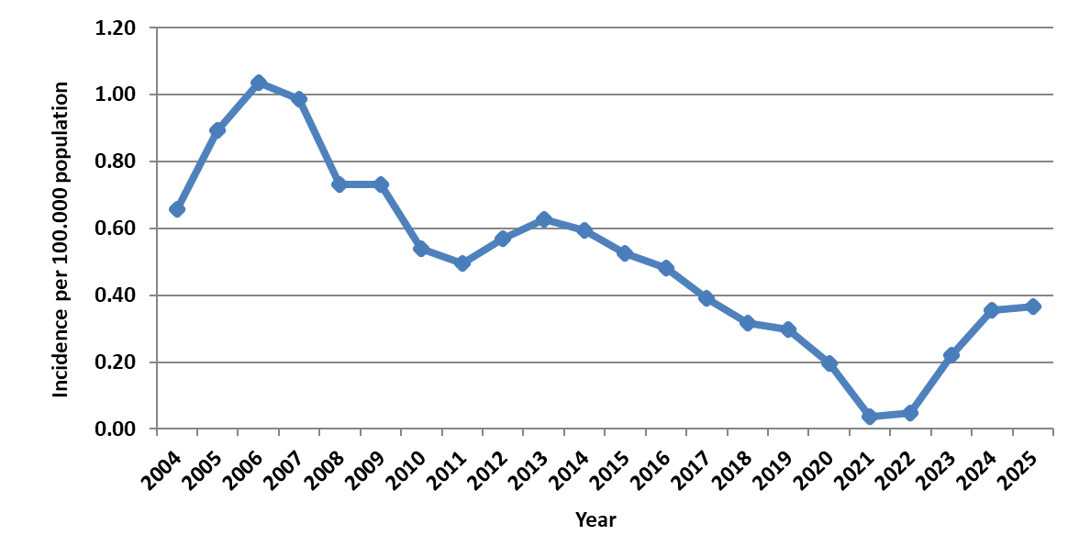
Age distribution
Between 2004 and 2025, a total of 1,207 IMD cases were recorded with a known date of birth, while one case lacked this information. The disease was most prevalent among children aged 0-4 years, with a mean annual notification rate of 3.94 cases per 100,000 population. The mean annual notification rate decreased progressively in older age groups, reaching 0.96 cases per 100,000 population in the 5-14 age group and 0.92 cases per 100,000 population in the 15-24 age group. For individuals aged 25 years and older, the mean annual notification rate did not exceed 0.21 cases per 100,000 population (Figure 2).
Figure 2. Mean annual notification rate of invasive meningococcal disease (cases/100,000 population) per age group in Greece, 2004-2025
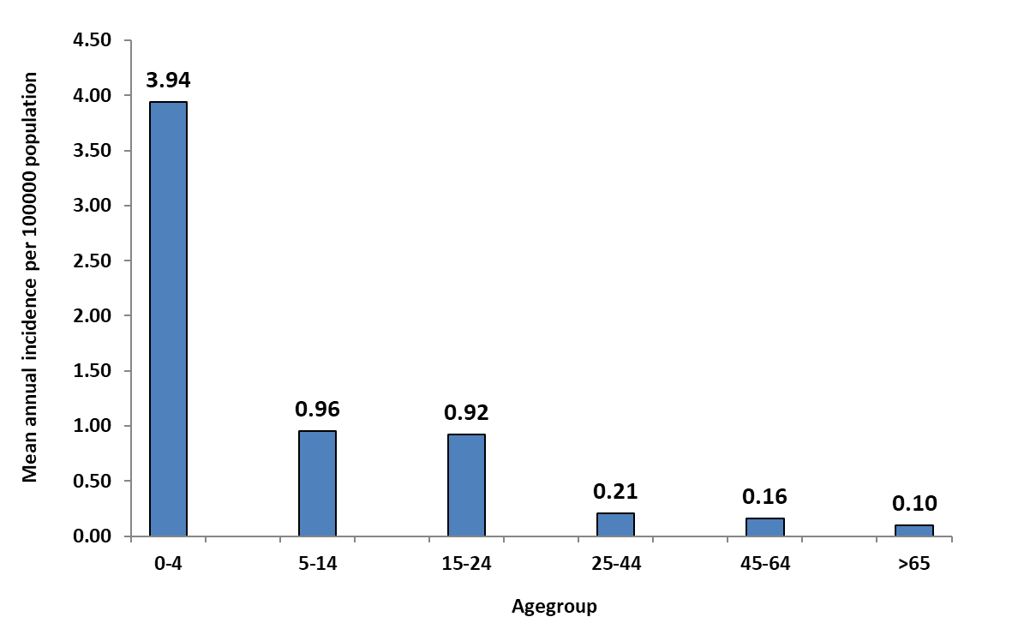
Laboratory data
Between 2004 and 2025, 95.3% (1,155 out of 1,212) of IMD cases were laboratory confirmed. During this period, 80.4% (975 out of 1,212) of cases underwent serotyping, with 94.1% (917 out of 975) identified to belong to one of the five main serogroups—A, B, C, W135, and Y—responsible for most invasive meningococcal infections globally. Additionally, in 2014, one case was identified to belong to serogroup X. In Greece, 81.3% (793 out of 975) of IMD cases were attributed to serogroup B, followed by serogroup C (Graph 3).
Figure 3. Distribution of invasive meningococcal disease by serogroup in Greece, 2004-2025
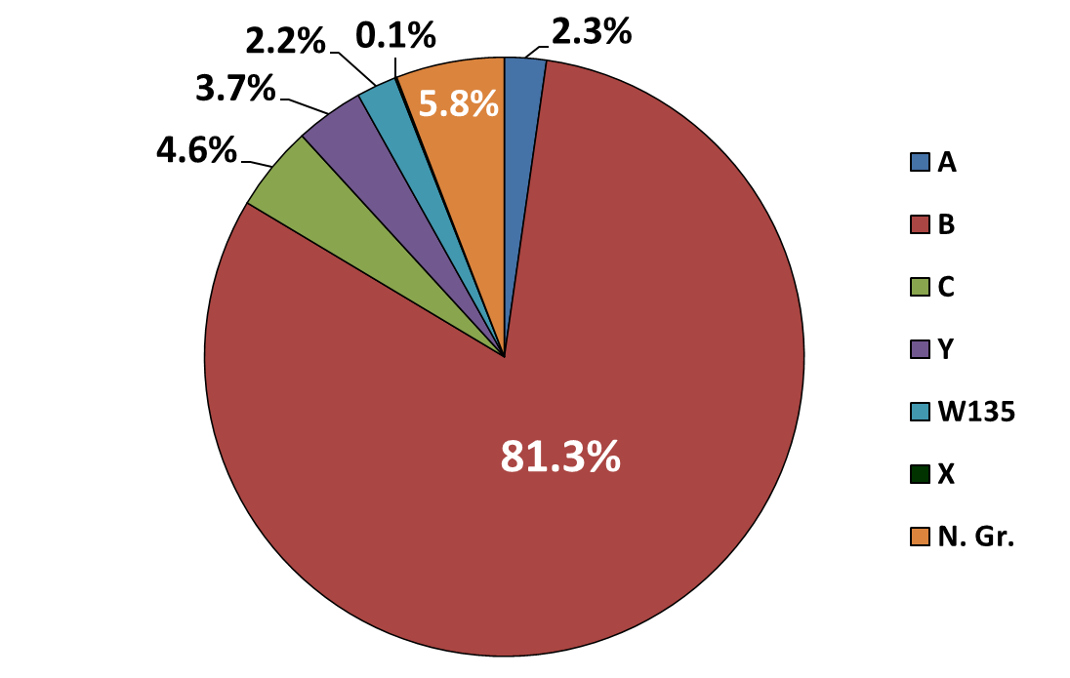

Fatality and Mortality rates
During 2004-2025, 72 deaths due to IMD were recorded, indicating a case fatality rate of 6%. The highest fatality rate was observed in the year 2018 (11.8%) while no fatalities were reported during the years 2020-2022. The mean annual mortality rate for the period 2004-2025 was 0.03 deaths per 100,000 population.
Prevention and Control Measures for IMD
A. Vaccination
In Greece, the National Immunisation Programme includes a monovalent meningococcal vaccine against serogroup C, a quadrivalent conjugate vaccine covering serogroups A, C, W135 and Y, as well as a vaccine targeting serogroup B.
The conjugate monovalent serogroup C vaccine (MCC) is administered as a single dose at 10 months of age. MCC vaccination has been shown to effectively control serogroup C disease in countries where systematic immunisation has been implemented, such as the United Kingdom.
The quadrivalent conjugate meningococcal vaccine (MCV4), covering serogroups A, C, W135 and Y, is recommended at 11–12 years of age (with catch‑up vaccination up to 18 years), regardless of prior MCC vaccination. In addition, MCV4 is recommended for infants ≥2 months, children and adolescents belonging to high‑risk groups, with the vaccination schedule adapted to the age at diagnosis and initiation of vaccination. If MCC has been administered previously, the first dose of MCV4 should be given at least one month later.
A protein‑based vaccine against serogroup B is also available in Greece (MenB‑4C, with a minimum age of administration at 6 weeks, or MenB‑fHbp, with a minimum age of 10 years). MenB‑4C is administered to healthy infants in two doses at 2 and 4 months of age, followed by a booster at 12–15 months. Given the epidemiology of the disease, the first dose in healthy infants should be administered immediately after completing 2 months of age and no later than 6 months; the second dose should be given by 12 months, and the booster by 18 months. MenB vaccination is also recommended for infants from 2 months of age and for children up to 18 years who belong to high‑risk groups, with the schedule adjusted according to the age at initiation.
B. Administration of Chemoprophylaxis to Close Contacts
Chemoprophylaxis should be administered as soon as possible to all individuals who had close contact with a confirmed case of IMD within the 7 days preceding the onset of symptoms, provided no medical contraindications exist (for the definition of close contacts, see: https://eody.gov.gr/el/nosimata/metadotika/nosimata-kai-themata-ygeias/meningitida-bakteriake.html?me=m3 ). Ideally, chemoprophylaxis should be given within the first 24 hours after the identification of the index case, as the risk of secondary disease among close contacts is highest during the first days following symptom onset in the index case [2,7]. Chemoprophylaxis is not considered useful if more than 10 days have passed since the last exposure to the case [3].
Rifampicin is the drug of choice, administered twice daily for two days [3]. Alternative options include a single intramuscular dose of ceftriaxone or a single oral dose of ciprofloxacin in adults. These antibiotics effectively reduce nasopharyngeal carriage and achieve eradication of Neisseria meningitidis in approximately 90–95% [2,7].
Conclusion
IMD remains rare both in Greece and in EU/EEA countries; however, it continues to be a severe and life‑threatening condition across all age groups. Compared with the pandemic period—during which the lowest reported incidence was recorded—there has been an increase in notified cases from 2023 onwards, with the notification rate returning to the low pre‑pandemic levels.
Serogroup B has consistently accounted for the majority of IMD cases in Greece, a pattern that mirrors surveillance findings across EU/EEA Member States. Cases caused by serogroup C—the second most frequent serogroup historically—remain particularly low, especially following the introduction of routine vaccination against this serogroup in Greece. It is also noteworthy that cases due to serogroups W135 and Y remain infrequent, in contrast to the increasing trends observed in some European countries. This difference may reflect the timely introduction of the quadrivalent meningococcal vaccine into the national immunisation programme.

Last update May 2026

